Program Features: Object-oriented Programming, Class Declarations, Constructor Functions, Accessor Functions.

Write a C++ program that creates a class of objects called complex. Use these objects to represent complex numbers. The two Data Members of the class shall be the real part and the imaginary part of the complex number.

The Member Functions of the class shall include:

A default constructor
A constructor that accepts the real part and the imaginary part as parameters

A function that sets the value of the real part
A function that sets the value of the imaginary part
A function that returns the real part of the complex number
A function that returns the imaginary part of the complex number
A function that returns the magnitude of the complex number
A function that returns the angle (in degrees) of the complex number
A function that returns the complex conjugate of the complex number

A function that displays the number in the form “real + j imaginary”
A function that displays the number in the form “magnitude at angle degrees”

Overload the following mathematical operators to accept complex objects as operands:

+ Complex Number Addition
– Complex Number Subtraction
* Complex Number Multiplication
/ Complex Number Division

Write a main function that demonstrates all of the capabilities of the class definition.

Document the project with the following:

A. A written description of the program.
This program uses a struct to define and work with complex numbers. It includes data members for the real and imaginary parts and provides functions to display the number, calculate its magnitude, and compute its angle in degrees. The program demonstrates creating a complex number and calling these functions in the main function. It is structured simply to help understand how structs and basic member functions work together.

B. A diagram to graphically illustrate the structure of the program.
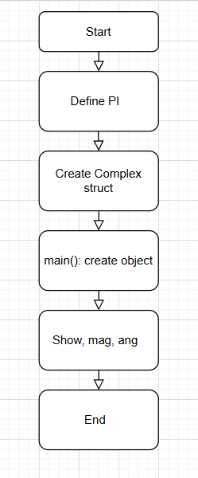

C. The code listing.

//ECE 2305 - Programming Project 10

#include <iostream>
#include <cmath>
using namespace std;

const double PI = 4 * atan(1.0);

struct Complex {
double real, imag;

Complex(double r = 0, double i = 0) {
real = r;
imag = i;
}

void show() {
cout << real << " + j" << imag << endl;
}

double mag() {
return sqrt(real * real + imag * imag);
}

double ang() {
return atan2(imag, real) * (180 / PI);
}
};

int main() {
Complex a(3, 4);

cout << "Complex number: ";
a.show();
cout << "Magnitude: " << a.mag() << endl;
cout << "Angle: " << a.ang() << " degrees" << endl;

return 0;
}
D. Screen shots that show the operation of the program.

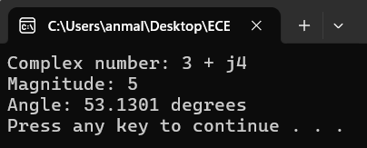
Submit the document on Blackboard.

